**IMPLEMENTATION OF CLASSES AND OBJECTS**

**AIM**: Write a java program to create a class Distance with data members' feet and inches.

**PROGRAM**:

/**

*

* @author 2162014

*/

import java.util.Scanner;

class Distance {

int feet, inch;

Distance() {

feet = 0;

inch = 0;

}

Distance(int ft, int in) {

feet = ft;

inch = in;

}

void readDistance() {

Scanner in = new Scanner(System.in);

System.out.println("Enter the distance: ");

System.out.println("Enter feet: ");

feet = in.nextInt();

System.out.println("Enter inch: ");

inch = in.nextInt();

}

void printDistance() {

System.out.println(feet + "\'" + inch + "\"");

}

void addDistance(Distance d) {

feet = this.feet + d.feet;

inch = this.inch + d.inch;

if (inch > 11) {

++feet;

inch -= 12;

}

}

}

public class Distanceaddition {

public static void main(String[] args) {

Distance d1 = new Distance();

Distance d2 = new Distance(3, 5);

d1.readDistance();

System.out.println("Distance D1:");

d1.printDistance();

System.out.println("Distance D2");

d2.printDistance();

System.out.println("Sum of two distances: ");

d1.addDistance(d2);

d1.printDistance();

}

}

**OUTPUTS**:

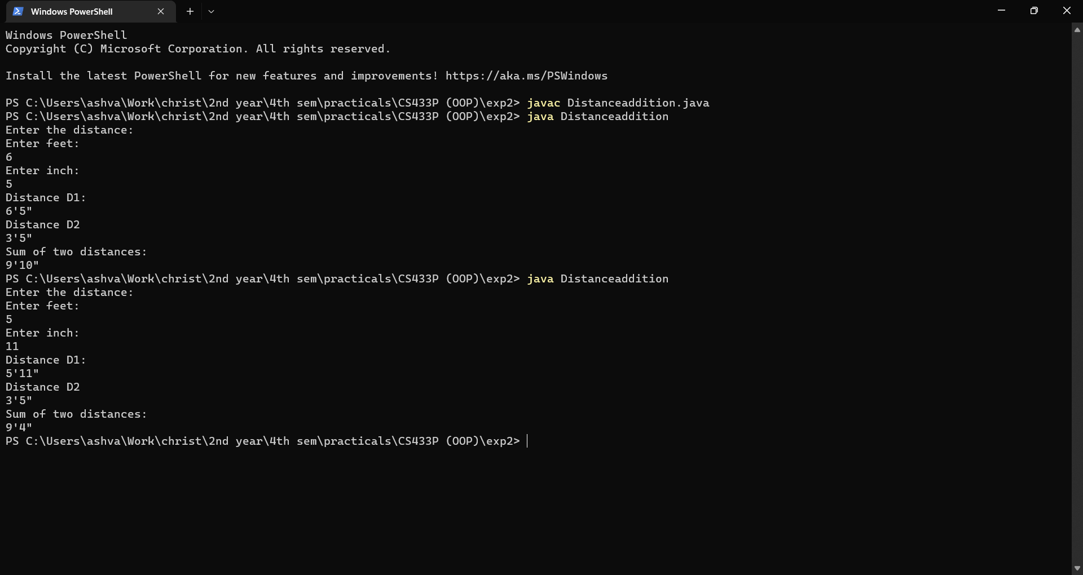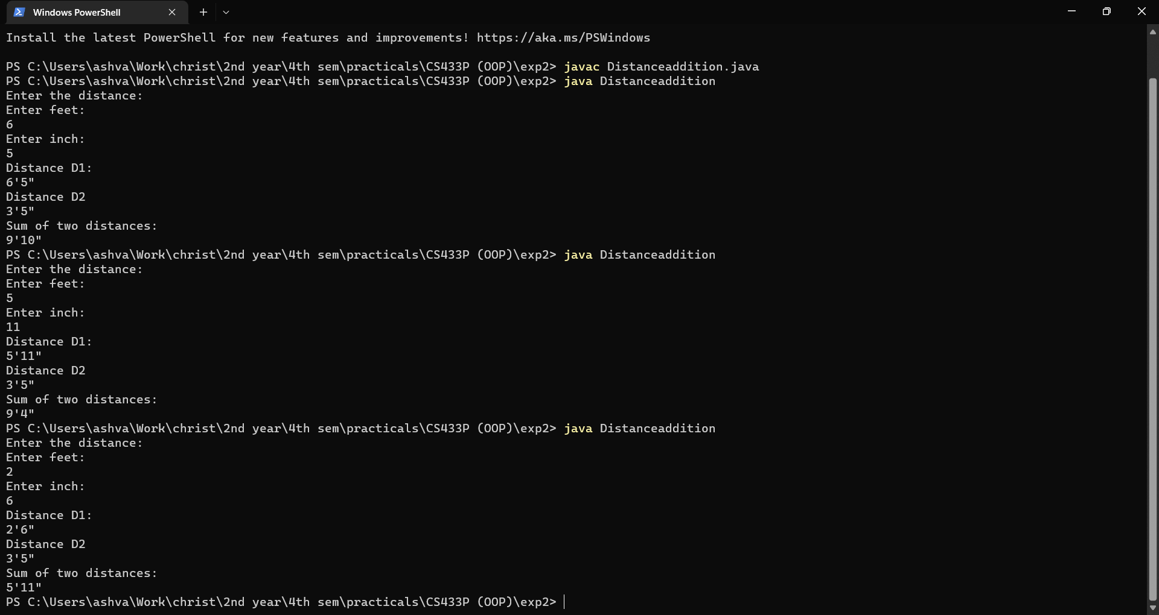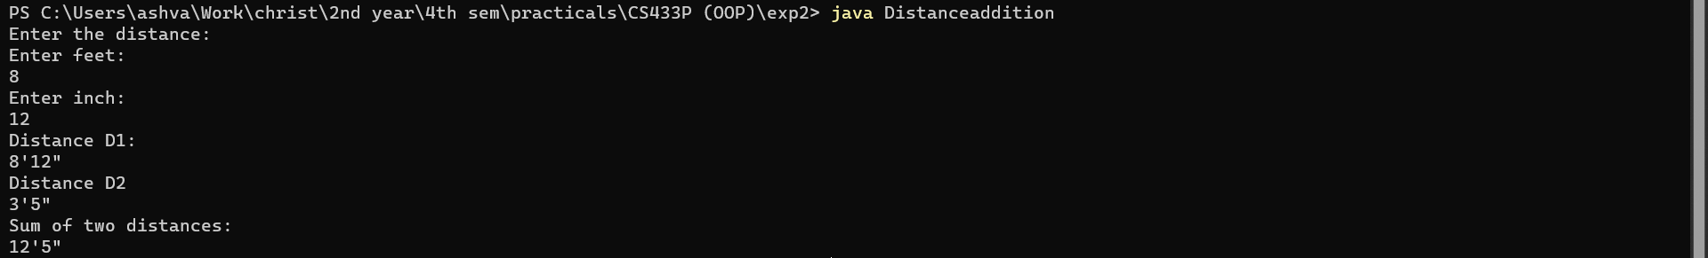

**RESULTS:**

The java program was created successfully to demonstrate classes and objects.